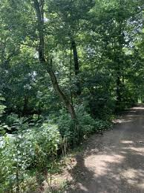
SECOND ANNUAL WABASHIKI WETLANDS WALK/RUN
BENEFITING THE CONSTRUCTION OF
WEST TERRE HAUTE CLINIC/PHARMACY
October 16, 2021 9:00 a.m.
Sponsored by Valley Professionals/Connecting Link
Please join us for our second annual Walk/Run on the walkway across the grade and on part of the Wabashiki trail. All proceeds will benefit the construction of the Valley Professionals Clinic and Pharmacy in West Terre Haute.

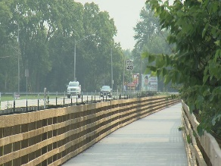
Registration begins at 8:30 a.m. The two-mile walk will begin at 9:00 a.m. at AmVets 222 (a.k.a. Kerman Grotto) and will finish at West Vigo Elementary School. Keith Ruble, former superintendent of Vigo County Parks, will be making remarks about various points of interest as we walk. (Or walk on your own, if you do not want to be in a crowd.)
Because the walk will not end where it begins, we would suggest that you partner with at least one other person to leave a car at the endpoint so that you can be driven back to your vehicle. An alternative would be to walk four miles – (walk the “official” walk and then retrace your steps to return to your car). Or create your own walk (e.g. AmVets 222 to Dewey Point and back, etc.!)
Because of the uptick in Covid cases in the area, face masks are strongly encouraged, particularly for those who will be walking in the large group.
Name ______________________________________________________________
Address_____________________________________________________________
City, State, Zip________________________________________________________
Phone____________________ Email: ____________________________________
Minimum Donation Requested: $10 Amount Paid: ___________________
Please make checks payable to Valley Professionals Community Health Center
Mail to: 777 South Main Street Suite 100 Clinton, IN 47842

